Grant Agreement No: 227579
EuCARD
European Coordination for Accelerator Research and Development
Seventh Framework Programme, Capacities Specific Programme, Research Infrastructures, Combination of Collaborative Project and Coordination and Support Action

deliverable report

Work Package Activity Report for PERIOD 2

Document identifier: | EuCARD-P2-WP4
Period: | From Month 19 to end of Month 36 (March 2012)
Report release date: | 17/05/2012
Work package: | WP4 “AccNet”
Work Package leader: | Frank Zimmermann, CERN; Peter Spiller, GSI; Walter Scandale, CNRS
Contributing authors: | Ralph Assmann, CERN; Jean-Marie De Conto, UJF; Mariusz Grecki, DESY; Jens Osterhoff, DESY; Ezio Todesco, CERN; Henri Videau, CNRS; Wolfgang Weingarten, CERN
Document status: | Draft

Abstract:
A report of the work performed during period 2 in Work Package 4 “Accelerator Science Networks” of the EuCARD project (the second 18 months - 1 October 2010 until 31 March 2012) including the work progress and the use of the resources.

WP4: Accelerator Science Networks (AccNet)

The accelerator science networks (WP4-AccNet) are the project platform for exchange, investigations and assessment of accelerator upgrades, technologies and new infrastructures. They included originally three, and now four tasks:
- Task WP4.1: Coordination and communication
- Task WP4.2: EuroLumi network (accelerator performance)
- Task WP4.3: RFTech network (RF technologies)
- Task WP4.4: EuroNNAc (novel accelerators)
During Period 2, the accelerator science networks (WP4-AccNet) have further grown and expanded. In this period AccNet-EuroLumi has initiated and organized six successful & high-impact workshops: the first ever workshop on a Higher-Energy LHC (HE-LHC) charted a promising path for the future of high-energy physics; a workshop on crystal collimation further pushed this technology for hadron storage rings; the fourth and fifth workshops on LHC crab cavities established a baseline scheme for LHC crab cavities (400 MHz, compact, local), a time schedule of crab cavity R&D for the High-Luminosity LHC, guidelines for partners in Europe and around the world, and a down-selection of 2 or 3 options among several proposed cavity designs; a bilateral GSI-CERN workshop on electron-cloud effects discussed modelling efforts and observations at the LHC and for FAIR; finally, a topical workshop on optics measurements and correction for high performance storage rings reviewed the state of the art, and fostered an exchange of methods and idea between all types of lepton and hadron beam facilities. EuroLumi coordinators delivered invited talks to annual meetings of the large LHC experiments (ATLAS and CMS), at the first Mexican Particle Accelerator School, and at various institutes in Japan. Collaborations with the European Space Agency and with ITER were strengthened by organizing joint events. A new collaboration with U. Kyoto was launched for the HE-LHC.
The second and third EuCARD-RFTech annual workshops, held at PSI and at the University of Rostock, respectively, brought together up to two times more experts than the first RFTech meeting. Most importantly, RFTech produced a strategy for SRF test facilities in Europe (WP4 deliverable, published as EuCARD monograph).
In the 2nd period, AccNet strengthened several important collaborations, including common R&D of CERN and GSI, joint conference organization, and exchanges with scientists and students from other institutes and universities, notably ESA/ESTEC (International, Netherlands & Spain), ITER (International, France), EPFL (Switzerland), KEK (Japan), U. Kyoto (Japan), U. Hiroshima (Japan), FNAL (USA), CINVESTAV (Mexico), INFN (Italy), CELLS/ALBA (Spain) and SLAC (USA). Additional financial support from CONACYT Mexico, inspired by an initial EuCARD investment, was used to support three visitors from CINVESTAV for continuing AccNet activities, such as electron-cloud studies, LHC crab-cavity failure modes, and work on a high-intensity H⁻ ion injector.
At the end of 2010, a new network (WP4.4), AccNet-EuroNNAc, was launched to identify possible usage of advanced accelerator techniques, such as plasma acceleration, in large-scale conventional facilities, and to develop a roadmap towards an advanced accelerator facility for big science. One major EuroNNAc conference was organized to kick-start this activity. EuroNNAc began to structure and focus the European R&D on advanced accelerators.
Overall there has been an excellent and still growing attendance to AccNet workshops from many European laboratories, universities, international organizations, and institutes in the USA, Mexico, and Japan. AccNet continued to make a significant impact on the most relevant topics, e.g., AccNet promoted the crab-cavity program for LHC, pursued collaborations and opened new avenues for e-cloud modeling & mitigation (e.g. carbon coating, clearing electrodes, magnetic surfaces), and pushed the High-Energy LHC. AccNet activities were cost efficient. AccNet supported the exchange of more than 20 expert visitors, and produced two PhD theses, 1 master thesis, more than 30 conference papers, 3 journal articles, and 3 EuCARD monographs. EuroLumi provided various inputs to the LHC upgrade, in particular to the strategy for LHC crab cavities, HL-LHC parameters, HL-LHC scenarios large crossing angle, flat-beam crab-waist scenario, electron-cloud mitigation, electron cloud in the HL-LHC, revisions of the LHC upgrade plans, and the LHC energy upgrade. RFTech organized the RF community. EuroNNAc started to organize community working on novel acceleration schemes. AccNet was breaking other new grounds, e.g. for plasma acceleration and crystal collimation. Last not least AccNet fostered exciting new contacts and synergies (ESA, CINVESTAV, VALSPACE, MIT, Kyoto U., Hiroshima U., ITER).

Task WP4.1: Coordination and communication

Throughout the programme, this task represents AccNet in EuCARD and to the outside. It also communicates achievements.

Progress towards objectives
At the 6th and 9th meetings of the EuCARD Steering Committee on 12-13 October 2010 and 1-2 December 2011 the status and plans of AccNet were reported.
In the 4th semester AccNet launched the new network EuroNNAc on the usage of plasma wake field acceleration. The scientific scope plus candidate participants for a possible fourth network, on medical accelerators were explored.
Presentations featuring and disseminating results of AccNet studies were given at various occasions during this period, e.g. at the German KET strategy workshop in Dortmund, the Chamonix LHC Performance workshops in 2011 and 2012, the second and third RFTech workshops, the first Mexican Accelerator School, U. Kyoto, U. Hiroshima, and at KEK, as well as at the annual week-long meetings of the large LHC experiments.
Several future AccNet mini-workshops and AccNet co-sponsored conferences have been prepared, e.g. on low-level RF for XFEL, on mixed design of integrated circuits and systems, and on optics measurement, correction and modelling for high-performance storage rings.
Early in 2011, all AccNet web sites were transferred from LAL to a CERN server for easier access and maintenance. The AccNet web site was continually updated and expanded. Budget and manpower plans were also updated and adjusted.
The fourth general AccNet Steering meeting will be held on 24 April 2012 (at WUT Warsaw).

Contractual milestones and deliverables
D4.1.1 – The AccNet web site was transferred to a CERN server and continually updated. It features the main objectives, the network structure, activity reports, a path to the WP4 Collaboration Workspace, workshops, literature and presentations, and links, as well as access to the web sites of the three tasks EuroLumi, RFTech, and EuroNNAc (new) and “Hot News”.
M4.1.3 – The third general AccNet Steering meeting was organized in May 2011 (at CNRS/France).

Planning, deviations and corrective actions
Task on schedule | √ | Ahead of schedule |  | Minor delay |  | Significant delay

Estimate of use of resources
 | Personnel |  |  |  |  | Material
Partner | ++ | + | = | - | -- | ++ | + | = | - | --
CERN |  |  | * |  |  |  |  | *
CNRS |  |  | * |  |  |  |  | *
GSI |  |  | * |  |  |  |  | *

Task WP4.2: EUROLUMI

Progress towards objectives

The EuCARD-AccNet-EuroLumi Workshop on a Higher-Energy Large Hadron Collider, ‘HE-LHC10,’ held on Malta, 14-16 October 2010, was the first ever workshop discussing the possibility of building a 33 TeV centre-of-mass energy proton–proton accelerator in the LHC tunnel. The key element of such a machine will be 20-T magnets. The workshop featured many discussions about Nb3Sn and high-temperature superconductor (HTS) accelerator-magnet development in Europe, the US, and Japan. It also discussed possible parameter sets, issues related to beam dynamics and synchrotron radiation handling, and the need for new injectors, possibly with 1 TeV energy. HE-LHC10 was attended by 56 participants from Europe, the Americas, and Japan, including 26 from CERN and 13 from the United States of America (primarily US-LARP partners).
The AccNet-EuCARD mini-workshop on crystal collimation, organized at CERN from 25 to 27 October 2010, focused on collimation procedures assisted by bent crystals and suitable for collimation during the high-luminosity phase of LHC and for new large colliders. The workshop featured a critical review of the results obtained in the SPS H8 line, discussed the results of collimation experiments in “low energy” storage rings, such as the SPS, and the possible use of bent crystals in the LHC collimation system, and surveyed other applications of crystals and alternative advanced methods of collimation in other laboratories. The workshop had 32 participants, about a third of whom from CERN, and others from Italy (INFN Ferrara, Legnaro, Napoli, Roma), Russia (JINR Dubna, IHEP Moscow, St. Petersburg), Germany (GSI Darmstadt), UK (Imperial College), USA (SLAC), and Switzerland (EPFL Lausanne).
The EuCARD-AccNet 4th workshop on crab cavities (LHC-CC10) for the LHC luminosity upgrade project (HL-LHC) was held from 15 to 17 December 2010 at CERN. This workshop was jointly organized by EuCARD, CERN, KEK and US-LARP. Approximately 50 participants from 3 continents participated in the workshop to discuss the future implementation of the crab cavities in the LHC and related issues. At LHC-CC10, local crab crossing with the aid of 400 MHz deflecting SRF cavities was identified as the baseline scheme for geometric luminosity-loss compensation and luminosity leveling at the HL-LHC. For associated key issues such as machine protection and robust operational scenarios, more detailed studies were requested in order to identify and mitigate potential beam-dynamics or technology limits on implementing and fully exploiting crab crossing at the LHC. LHC-CC10 also recommended that all measures to test future LHC prototype cavities with and without beam outside the LHC be taken in order to ensure robust operation of the crab RF structures in the LHC.
A bilateral EuCARD AccNet CERN-GSI electron-cloud workshop was organized with the main goal to review the status of CERN and GSI electron-cloud studies in order to find synergies between the two laboratories and to define a common strategy for future developments in terms of simulation tools, diagnostics and mitigation techniques for the LHC, SPS and FAIR. The workshop took place on 7–8 March 2011 at CERN, and welcomed 30 registered participants coming from CERN, GSI, INFN-LNF, KEK, CELLS, CINVESTAV, and several other institutes.
The EuCARD-AccNet Workshop Optics Measurements, Corrections and Modeling for High-Performance Storage Rings “OMCM” was held at CERN from 20 to 22 June 2011. It was attended by 59 persons from many institutes in Europe, US, and Japan. 46 presentations were given during the workshop and, due to overwhelming interest, three additional talks had to be delivered in the form of seminars the day after the workshop. OMCM sessions covered the motivation and tolerances for optics control at high-energy machines, colliders, high-intensity machines, light sources and damping rings; the experience at colliders, at high-energy and at high-intensity machines; the experience from light sources and damping rings; reviews of analysis techniques, modeling approaches, and beam diagnostics; present and future optics plans at the LHC complex; and general prospects and future developments.
The 5th Joint EuCARD/AccNet-LARP -KEK-CI/DL workshop on LHC crab cavities, “LHC-CC11,” was organized at CERN, 14-15 November 2011. This workshop had 52 participants from many institutes in Europe, US, and Japan, and featured a total of 34 presentations as well as a meeting of the LHC Crab-Cavity Advisory Board. The main results of LHC-CC11 were convergence to 2 (3) compact crab-cavity designs, the availability of first Al cavity prototypes, a detailed plan foreseeing a complete set of precise cavity specifications by spring 2012 based on the initial set of HL-LHC parameters, and declaring beam tests with compact cavity prototypes in the SPS and in the LHC as a pre-requisite for a final installation of the complete system in LHC Points 1 and 5.
EuCARD-AccNet also co-sponsored the MulCoPim’11 conference on multipactoring, corona discharge and pulse intermodulation, in Valencia, 21-23 September 2011, organized by the European Space Agency, with a dedicated session on accelerators. MulCoPim’11 was used to strengthen the ties between accelerator and spacecraft communities.
During 2011, several invited talks on the LHC upgrade plans were given for the two LHC high-luminosity experiments. Outreach talks on the LHC and LHC upgrade delivered in Japan (KEK, U. Hiroshima, U. Kyoto) initiated a new collaboration with U. Kyoto on HE-LHC magnet R&D.
During the 2nd period, AccNet-EuroLumi supported or organized a number of exchanges of scientists and joint studies. The Mexican doctoral student H. Maury (CINVESTAV/Merida) performed electron-cloud simulations for the LHC arcs considering various LHC beam-commissioning parameters as well as upgrade scenarios. The Mexican doctoral student B. Yee (CINVESTAV/Mexico City) simulated the effect of crab-cavity failures with regard to LHC machine protection. The Mexican doctoral student C. Valerio (CINVESTAV/Sonora) contributed to the development of a high-intensity H⁻ source. The US-LARP physicist C. Bhat (FNAL) continued to study the generation & stability of long flat bunches for the LHC, participated in pertinent machine studies, and developed a realistic parameter set for an LHC upgrade with “Large Piwinski Angle”. US-LARP physicist R. Calaga (BNL) co-organized the LHC-CC010 workshop and helped organizing the international collaboration on LHC crab cavities. The Italian expert S. Dabagov (INFN-LNF) contributed to the activity on crystal collimation. K. Ohmi (KEK) performed beam-beam and electron-cloud simulation studies for various LHC upgrade scenarios, including HE-LHC and HL-LHC with crab cavities. The Spanish expert U. Irizo (CELLS/ALBA) visited CERN two times in this period and contributed to electron-cloud simulation studies aimed at determining the LHC vacuum-chamber surface properties. The GSI expert G. Franchetti investigated advanced incoherent resonance-crossing phenomena and the electron-cloud pinch in quadrupole magnets. US specialists G. Decker (ANL) and M. Plum (ORNL/SNS) visited CERN for discussions on optics diagnostics and optics modeling for high-intensity proton rings, respectively. The Italian surface scientist R. Cimino (INFN-LNF) presented ideas on electron-cloud mitigation, e.g. using in-situ fullerene coatings.
The fourth annual EuroLumi steering meeting will be held in April 2012. The plan for the final two semesters includes a joint AccNet-EuroLumi-INFN workshop on electron cloud & mitigation, ECLOUD’12, in Italy, 5-9 June 2012; organizing two dedicated EuroLumi & RFTech sessions during the AccNet co-sponsored conference on Computational Accelerator Physics, ICAP12, in Germany; a joint topical LHC-FAIR workshop (on dynamic vacuum, beam instrumentation and/or magnet-setting generation), an AccNet-EuroLumi working meeting on short bunch length for the LHC, the 6th EuCARD-AccNet Workshop on LHC Crab Cavities, “LHC-CC12,” combined with a HiLumi LHC workshop, Frascati, November 2012, and a second AccNetEuroLumi workshop on the HE-LHC.

Contractual milestones and deliverables
D4.2.1 – The EuroLumi web site was transferred to a CERN server and continually updated.
M4.2.2 & M4.2.3 – Instead of a single Annual EuroLumi workshop, during this period six EuroLumi topical workshops were organized: CERN-GSI Electron-Cloud Workshop (CERN, 7-8 March 2011); LHC-CC10 - the 4th LHC Crab Cavity Workshop, CERN (15-17 December 2010); a Workshop on Crystal Collimation, CERN (25-26 October 2010); HE-LHC'10 Mini-Workshop on High-Energy LHC, (Malta, 14-16 October 2010); OMCM – Optics Measurement, Correction and Modelling for High Performance Storage Rings (CERN, 20-21 June 2011); and LHC-CC11 – the 5th LHC Crab Cavity Workshop (CERN, 14-15 November 2011). The topical workshops have proven a highly efficient vehicle for making progress and creating momentum. The largest of these were the workshops on a higher-energy LHC, with 56 participants, and on optics measurements & corrections, with 59 participants. All AccNet workshops and links can be found at http://accnet.web.cern.ch/accnet/Workshops/index.php .

Planning, deviations and corrective actions
Task on schedule |  | Ahead of schedule | √ | Minor delay |  | Significant delay

Estimate of use of resources

 | Personnel |  |  |  |  | Material
Partner | ++ | + | = | - | -- | ++ | + | = | - | --
CERN |  |  | * |  |  |  |  | *

Task WP4.3: RFTECH

Progress towards objectives

Highlights of this period were the second and third RFTech workshop, held at Paul Scherrer Institute (Switzerland), on 2-3 December 2010, with 30 participants, and in Rostock on 12 and 13 December 2011, with 16 participants, respectively. These workshops provided excellent opportunities to share experience among several fields of RF technology, from low-level systems to solid-state power amplifiers.

More specifically, the 2nd RFTech workshop covered the following topics: 1) Low Level RF: CERN's PS complex LLRF renovation, proposal for the SuperB project, status of the FLASH system, as well as the use of specific components like uTCA for XFEL machines, with presentations by specialists form CERN, CNRS and DESY. 2) Solid State Amplifiers, including both general presentations and particular techniques for this technology (with presentations from GANIL and CERN), as well as some specific developments, like at PSI, ESRF and SOLEIL (presentations by PSI and SOLEIL specialists). 3) RF technology for FELs, comprising normal- and superconducting RF aspects (X Band structures, the Swiss FEL project, cryomodule technology) with presentations by specialists from CEA and PSI, and a summary of the XFEL RF synchronization workshop (presentation from Warsaw University). 4) RF limitations related to the LHC ultimate beam with two presentations by CERN experts. 5) Cavity optimization, such as crab-cavity design for the LHC and high-order-mode free copper cavities (with talks given by BNL, CERN, Lancaster University and ESRF). 6) Superconducting RF, e.g. cryomodule assembly in Saclay, SRF infrastructures in Saclay/Orsay, SBT in Grenoble, with an analysis and a round-table discussion on the need of a European SRF test infrastructure for R&D and test of cavities & cryomodules. Part of the 2nd RFTech workshop has been used to present the work of young scientists, in order to exchange information, ideas and advices about cavity RF design or theoretical modelling.
Part of the third RFTECH workshop was devoted to electromagnetic fields computation (finite integration and finite elements methods, perturbative computation), cavity RF models (coupled multicell cavities with beam, cavity model and experimental validation for gradient flatness procedure). Another part was devoted to Low Level RF and regulation. Some general topics were presented (RF panorama at CERN, activities at Darmstadt and GANIL-Spiral2) as well as specific topics (RF aspects of crab cavities).
Several RFTech experts attended the workshop on X-Band RF technology, XB-10, on X-band RF structures, beam dynamics and sources, at the Cockcroft Institute (UK), 30.11-3.12.2010; a workshop on Advanced Techniques in LLRF control for XFEL at the Polish Academy of Sciences, 18.-20.04.2011; the special AccNet xTCA session for instrumentation at the MIXDES Conference 2011, Gliwice, 16-18.06.2011 (gathering interesting projects based on xTCA standards developed for LLRF FLASH and XFEL (DESY) and CODAC (ITER!)); the LLRF workshop 2011, Hamburg, 17.-21.10.2011 (review of the low-level RF system at various laboratories with working groups on software, hardware and systems); and a meeting on System Integration LLRF collaboration, WYT, 14-16.12.2011 (integration of hardware and software solutions for the LLRF and synchronization systems at FLASH and XFEL; effective usage of available resources and unification of developments).
The plan for the next two semesters includes the fourth annual RFTech steering meeting in April 2012; the AccNet(-RFTech) co-sponsored MIXDES2012 conference, Warsaw, in May 2012; an AccNet-RFTech meeting on energy efficient systems in the summer of 2012; the AccNet-RFTech co-sponsored workshop on Higher-Order-Mode Diagnostics and Suppression in Superconducting Cavities, HOMSC12, Daresbury, UK , 25-27 June 2012; the AccNet co-sponsored ICAP’12 conference with a dedicated RFTech session; and the fourth annual RFTech workshop, at Grenoble in December 2012.

Contractual milestones and deliverables
D.4.3.1 – The RFTech web site was transferred to a CERN server and continually updated.
D4.3.2 – Strategy/result for SRF test infrastructures. The final strategy report has been published as EuCARD monograph.
M.4.3.2 – The second annual RFTech workshop was organized in December 2010 at PSI (Switzerland)
M.4.3.3 – The third annual RFTech workshop was organized in December 2011 at Rostock University (Germany)

Planning, deviations and corrective actions
Task on schedule | √ | Ahead of schedule |  | Minor delay |  | Significant delay

Estimate of use of resources
 | Personnel |  |  |  |  | Material
Partner | ++ | + | = | - | -- | ++ | + | = | - | --
CERN |  |  | * |  |  |  |  | *
DESY |  |  | * |  |  |  |  | *
UJF |  |  | * |  |  |  |  | *

Task WP4.4: EURONNAC
EuroNNAc – a European Network for Novel Accelerators looking at the Next Generation of Novel Electron Accelerators – was launched in December 2010.

Progress towards objectives
A first major EuroNNAc workshop was held from 3 to 6 May 2011 at CERN. This workshop firmly established the new network and defined the work path towards novel accelerator facilities in Europe. About 93 expert participants from around the world participated and 46 presentations were given.
A preparatory meeting of the EuroNNAc organisation committee was held on 8 April 2011 at the Ecole Polytechnique in Paris.
A letter of intent (LOI) for a demonstration experiment on proton driven plasma wakefield acceleration (PDPWA) using a proton beam from the CERN SPS was drafted and finalized. This LOI was submitted to the CERN SPSC Committee, which in October 2011 delivered a positive review and encouragements to proceed towards a TDR.
The German experts A. Caldwell and G. Xia (MPI Munich) helped to organize and coordinate the PDPWA effort. A pertinent PDPWA workshop was organized at the University College London, 10-11 February 2011.
The second major EuroNNAc workshop will be held at CERN, 2-4 May 2012, with 5 goals: organizing three working groups; defining strategies and detailed plans per working group, aimed at a coherent proposal for one or a few European and international pilot facilities for advanced accelerators; preparing a written report on novel acceleration and the EuroNNAc network; approving plans for a European conference for advanced accelerators (the first to take place in 2013), and preparing input to European Strategy for Particle Physics.

Contractual milestones and deliverables
There are no deliverables, nor milestones. The first EuroNNAc workshop was organized at CERN in May 2011.

Planning, deviations and corrective actions
Task on schedule | √ | Ahead of schedule |  | Minor delay |  | Significant delay

Estimate of use of resources
 | Personnel |  |  |  |  | Material
Partner | ++ | + | = | - | -- | ++ | + | = | - | --
CERN |  |  | * |  |  |  |  | *
DESY |  |  | * |  |  |  |  | *
CNRS |  |  |  | * |  |  |  |  | *

WP4 PUBLICATIONS in seconD period

WP 4.1: (published earlier, in first period: 12)
H. Maury Cuna, J.G. Contreras, F. Zimmermann, Simulations of electron-cloud heat load for the cold arcs of the CERN Large Hadron Collider and its high-luminosity upgrade scenarios, PRST-AB 15, 051001, May 2012, EuCARD-PUB-2012-003
F. Zimmermann, EuCARD WP4 Accelerator Networks, Report at 9th EuCARD Steering Committee Meeting, GSI Darmstadt, 1 December 2011
F. Zimmermann, Hadron Colliders, Invited Lecture at First Mexican Particle Accelerator School ‘MePAS”, Guanajuato, 7 October 2011
F. Zimmermann, LHC Performance – Status & Future Plans, Kyoto U., 22 July 2011
F. Zimmermann, LHC Performance – Status & Future Plans, Hiroshima U., 19 July 2011
F. Zimmermann, LHC Performance & Future Plans, KEK, 1 July 2011
G. Franchetti, WP4 Highlight talk: Multiple Resonance Crossings with Space Charge and Electron Cloud, 2nd EuCARD Annual Meeting, CNRS, Paris, 22 May 2011
E. Todesco, WP4 Highlight talk: Higher energy LHC, 2nd EuCARD Annual Meeting, CNRS, Paris, 22 May 2011
R. Assmann, WP4 Highlight talk: The New Laser and Plasma Acceleration Network, 2nd EuCARD Annual Meeting, CNRS, Paris, 22 May 2011
F. Zimmermann, EuCARD WP4 Accelerator Networks, Report at 2nd EuCARD Annual Meeting, CNRS, Paris, 11 May 2011
F. Zimmermann, EuroLumi2 and/or AccNet2 in EuCARD2 Report at ESGARD Meeting, CNRS, Paris, 10 May 2011
F. Zimmermann, EuCARD WP4 Accelerator Networks, Report at 5th EuCARD Steering Committee Meeting Malta, 11 October 2010
F. Zimmermann, Outlook for PWA Experiments, KET Strategy Workshop, Dortmund, 25-26 October 2010
K. Pozniak Modeling of Synchronous Data Streams Processing in the RPC Muon Trigger System of the CMS Experiment, Intl Journal of Electronics and Telecommunications, 2010, VOL. 56, NO. 4, PP. 489–502, EuCARD-PUB-2010-019 (2010)
K. Kahle, W. Scandale, Crystal clear ideas for beam collimation, EuCARD Newsletter no 7 (December 2010)
K. Kahle, R. Assmann, A knack for novel acceleration techniques, EuCARD Newsletter no 7 (December 2010)
N. Wyles, F. Zimmermann, E. Todesco, Proposed increase in energy takes LHC even further into the future, EuCARD Newsletter no 8 (March 2011)
WP 4.2: (published earlier, in first period: 23)
K. Ohmi, R. Tomas, Y. Funakoshi, R. Calaga T. Ieiri, Y. Morita, K. Nakanishi, K. Oide, Y. Ohnishi, Y. Sum, M. Tobiyama, F. Zimmermann, Response of colliding beam-beam system to harmonic excitation due to crab-cavity RF phase modulation, PRST-AB 14, 111003, EuCARD-Pub-2012-002
H. Maury Cuna, F. Zimmermann, Electron Cloud with Inverted Beam Screens, 6 December 2011, EuCARD-REP-2011-008
R. Bartolini, O. Bruning, R. Calaga, D. Einfeld, M. Giovannozzi, J.-P. Koutchouk, C. Milardi, J. Safranek, R. Tomas, J. Wenninger, F. Zimmermann, Summary of the AccNet EuCARD Workshop on Optics Measurements, Corrections and Modelling for High-Performance Storage Rings “OMCM,” CERN, Geneva 20-22 June 2011, EuCARD-CON-2012-004
F. Zimmermann, Machine Progress Towards Higher Luminosity, CMS Upgrade Meeting, FNAL, Chicago 7 November 2011
O. Dominguez, U. Iriso, H. Maury Cuna, G. Rumolo, F. Zimmermann, Benchmarking Electron Cloud Build-Up and Heat-Load Simulations against Large-Hadron-Collider Observations, MulCoPim2011 Valencia, 21-23 September 2011, EuCARD-PUB-2011-011
C.M. Bhat, F. Zimmermann, LHC Luminosity Upgrade with Large Piwinski Angle Scheme; A Recent Look, IPAC’11 San Sebastian, EuCARD-CON-2011-051
G. Franchetti, F. Zimmermann, Electron-Cloud Pinch Dynamics in Presence of Lattice Magnet Fields, IPAC’11 San Sebastian, EuCARD-CON-2011-054
O. Dominguez, G. Arduini, V. Baglin, G. Bregliozzi, J.M. Jimenez, E. Metral, G. Rumolo, D. Schulte, F. Zimmermann, Electron Cloud Parameterization Studies in the LHC, IPAC’11 San Sebastian, EuCARD-CON-2011-053
O. Dominguez, F. Zimmermann, Luminosity Optimization for a Higher-Energy LHC, IPAC’11 San Sebastian, EuCARD-CON-2011-052,
H. Maury Cuna, G. Arduini, G. Rumolo, L. Tavian, F. Zimmermann, Simulation of Electron-Cloud Build-Up for the Cold Arcs of the LHC and Comparison with Measured Data, IPAC’11 San Sebastian, EuCARD-CON-2011-050
T. Baer, R. Calaga, R. Tomas, J. Tuckmantel, J. Wenninger, F. Zimmermann, LHC Machine Protection Against Very Fast Crab-cavity Failures, IPAC’11 San Sebastian, EuCARD-CON-2011-048
R. Cimino, A Surface Study on the Origin of SEY Reduction on Accelerator Walls, CERN, 29 July 2011
F. Zimmermann, LHC Machine Status & Plans, ATLAS Week, CERN, 20 June 2011
E. Todesco and F. Zimmermann (eds), The Higher-Energy Large Hadron Collider, Proceedings of the EuCARD-AccNet HE-LHC workshop, Malta, 14-16 October 2010, CERN, EuCARD-CON-2011-001
D. Shatilov, E. Levichev, E. Simonow. M. Zobov, Application of Frequency Map Analysis to Beam-Beam Effects Study in Crab Waist Collision Scheme, PRST-AB 14, 014001 (2011)
R. Calaga, Crab Status and Plans, US-LARP CM15 Collaboration Meeting, SLAC, 1-3 November 2010
R. Calaga (BNL), S. Myers (CERN), F. Zimmermann (CERN), Summary of the 4th LHC Crab Cavity Workshop "LHC-CC10", EuCARD-REP-2011-001 (2011)
F. Zimmermann, HL-LHC: parameter space, constraints and possible options, Proc. Chamonix 2011 workshop on LHC performance, CERN-ATS-2011-005 (2011)
U. Iriso (CELLS/ALBA), Electron Clouds Thresholds with 75 ns Bunch Spacing, 11 February 2011
R. Calaga, T. Baer, J. Barranco, R. Tomas, J. Wenninger, B. Yee, F. Zimmermann, Beam Losses due to Abrupt Crab Cavity Failures in the LHC, PAC2011 New York, EuCARD-CON-2011-004
G. Rumolo, F. Zimmermann, and O. Boine-Frankenheim, Summary of EuCARD-AccNet CERN-GSI Workshop on Electron Cloud, CERN, Geneva, 7-8 March 2011
WP 4.3: (published earlier, in first period: 17)
W. Weingarten, European Infrastructures for R&D and Test of Superconducting Radio-Frequency Cavities and Cryo-Modules, EuCARD Monograph Series, Vol. 10, EuCARD-BOO-2011-002
V. Khan, A Damped and Detuned Accelerating Structure for the Main Linacs of the Compact Linear Collider, PhD Thesis, U. Manchester, September 2011, EucARD-BOO-2011-001
W. Weingarten, Strategy/Result for SRF Test Infrastructures, EuCARD-MIS-2011-003
W. Weingarten, Is there a need for a 'European Infrastructure for R&D and Test of SRF cavities and cryomodules? 2 November 2010, EuCARD-PRE-2010-030
F. Zimmermann, LHeC Linac-Ring Option, 2nd RFTech Workshop, PSI, 2-3 December 2010
WP 4.4: (published in first period: 0 [WP4.4 not existing])
S. Hillenbrand, R.W. Assmann, F. Zimmermann, A.-S. Müller, T. Tückmantel, Energy Spectrometer Studies for Proton-Driven Plasma Acceleration, IPAC’11 San Sebastian, EuCARD-CON-2011-056
R.W. Assmann, I. Efthymiopoulos, S. Fartoukh, G. Geschonke, B. Goddard, C. Hessler, S. Hillenbrand, M. Meddahi, S. Roesler, F. Zimmermann, A. Caldwell, P. Muggli, G. Xia, Studies on a possible Experiment on Proton-Driven Plasma Wakefields at CERN, IPAC’11 San Sebastian, EuCARD-CON-2011-055
G.X. Xia et al, A Proposed Experimental Test of Proton-Driven Plasma Wakefield Acceleration Based on CERN SPS, PAC2011 New York, EuCARD-CON-2011-003
G.X. Xia et al, Update on Proton Driven Plasma Wakefield Acceleration, Proc. AAC’10, 13-19 June 2010, Annapolis, MD (2011), EuCARD-CON-2010-072

Highlight pictures
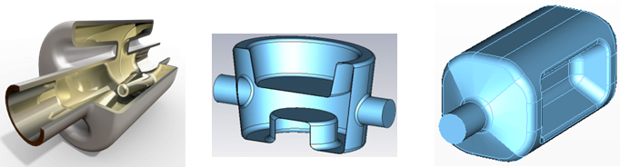
Figure: Final down-selected compact cavity designs for the LHC upgrade: 4-rod cavity design by Cockcroft I. & JLAB (left), λ/4 TEM cavity by BNL (centre), and double-ridge λ/2 TEM cavity by SLAC & ODU (right).
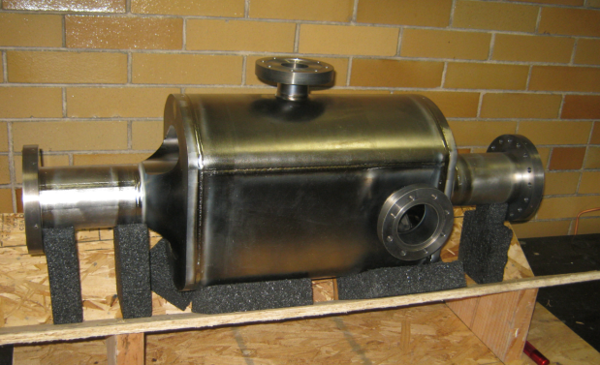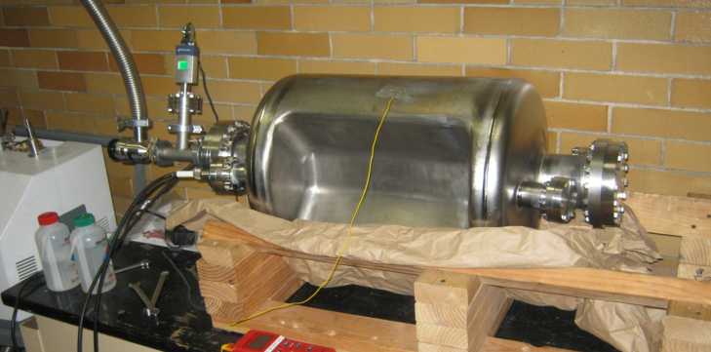
Figure: Prototype compact Nb-Ti crab cavities for the LHC: 4-rod cavity (left) and double-ridge cavity (right).
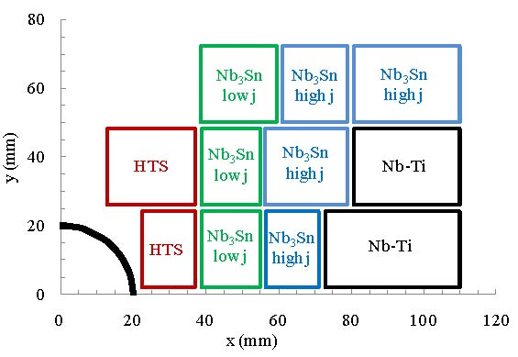
Figure: Block layout of a proposed Nb-Ti & Nb3Sn & HTS 20-T HE-LHC dipole-magnet coil [E. Todesco & L. Rossi]. Only one quarter of one aperture is shown.
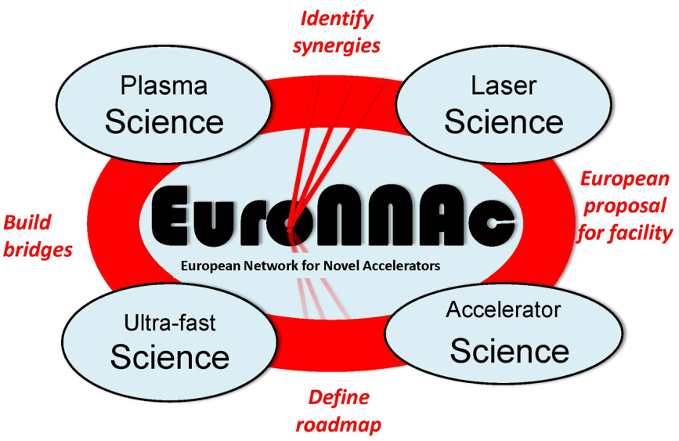
Figure: Diagram illustrating the strategic functions of the new WP4.4 “EuroNNAc”.

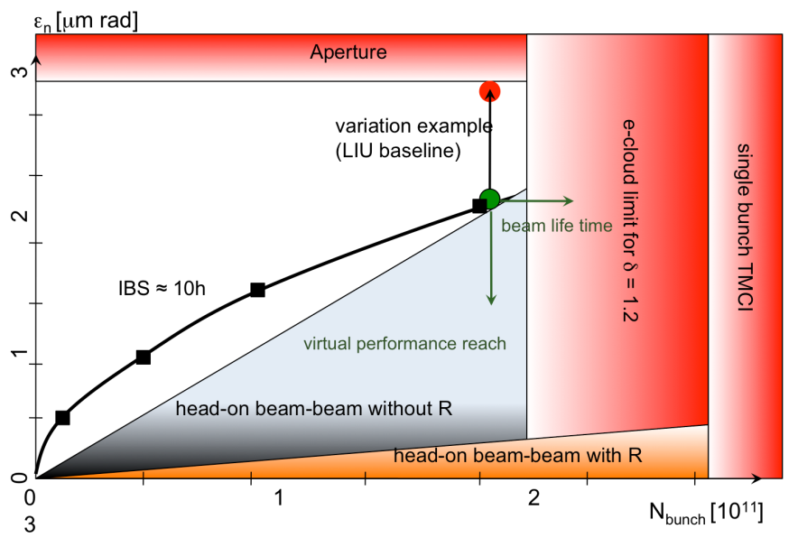
Figure: Parameter space for the LHC high-luminosity upgrade.

